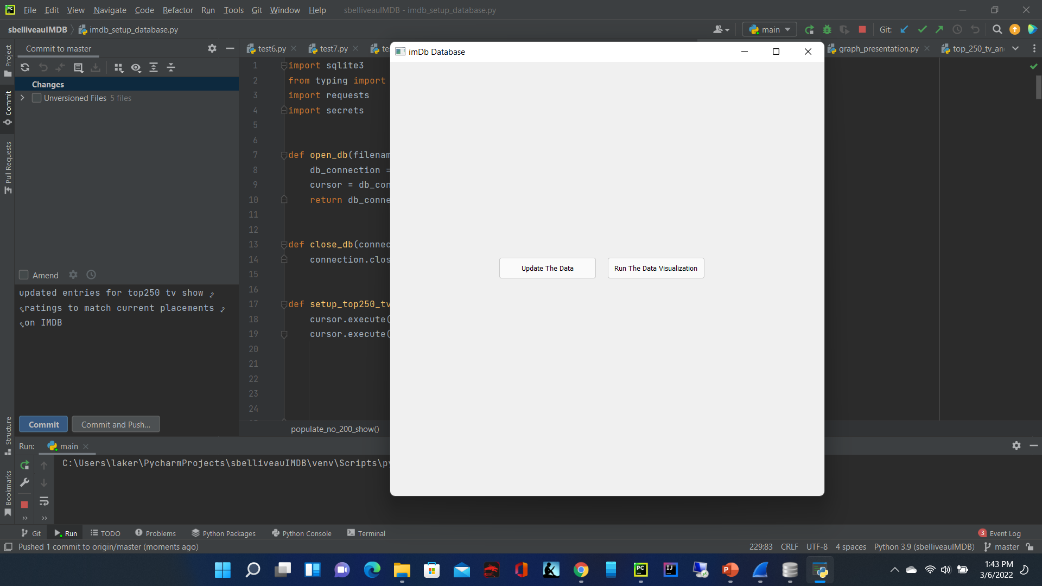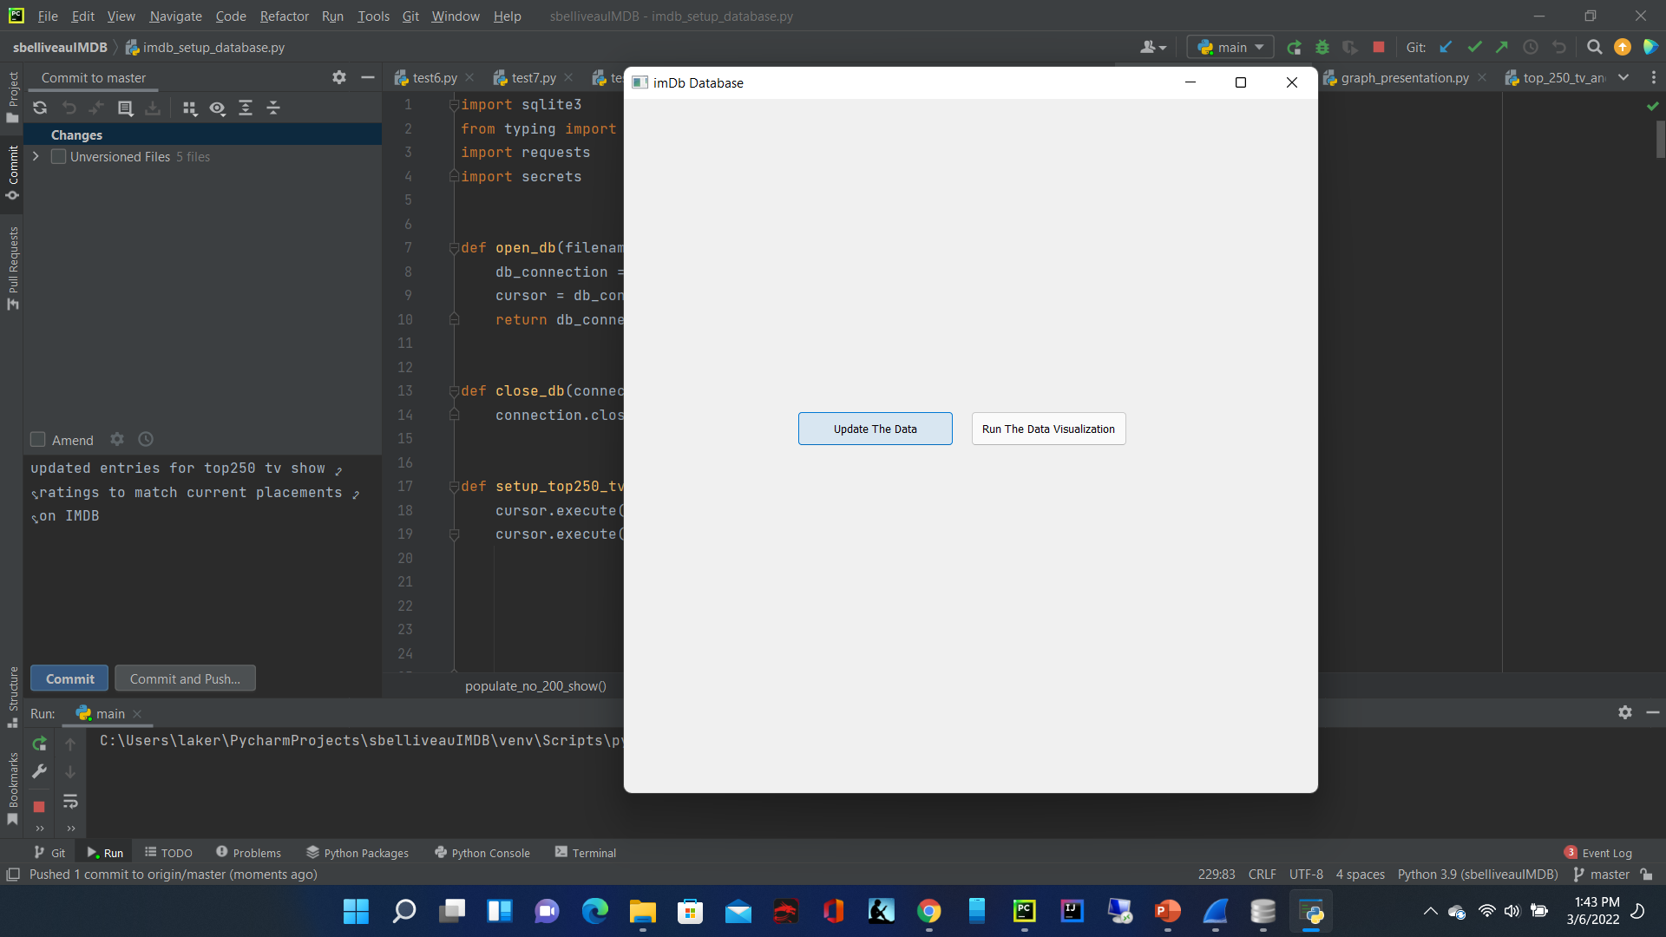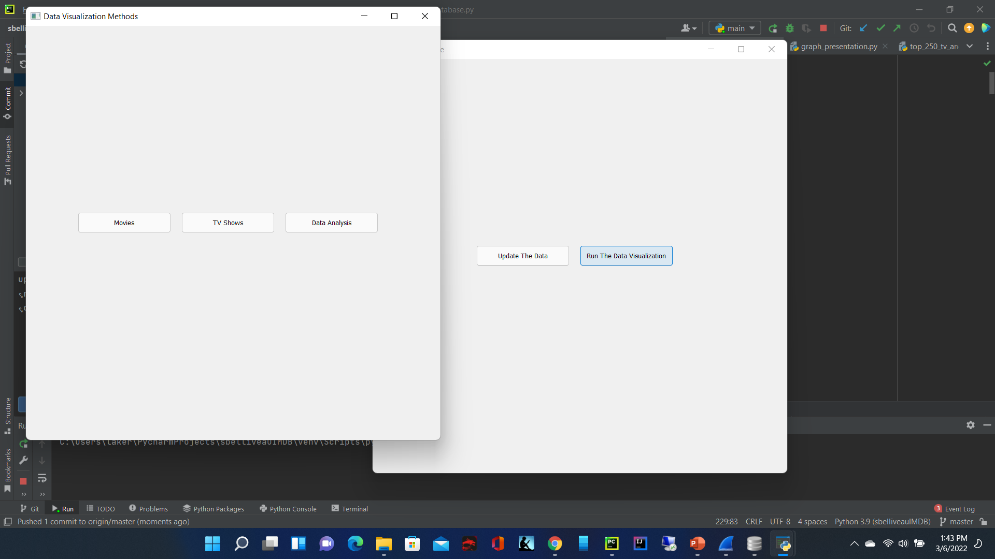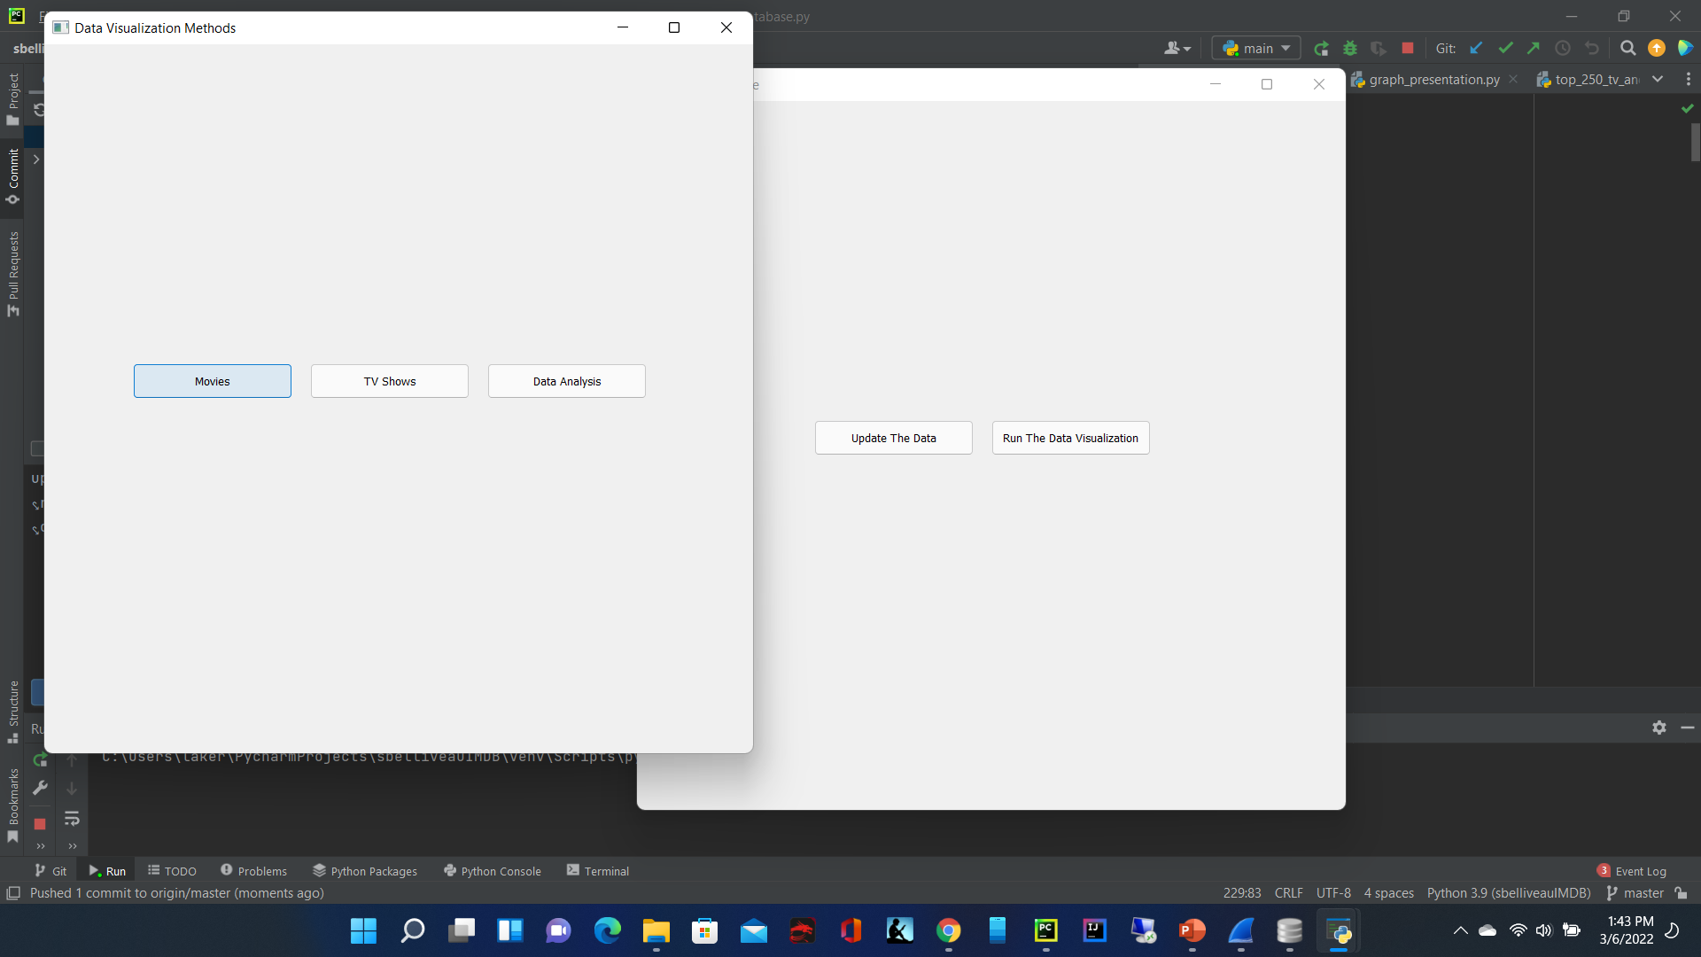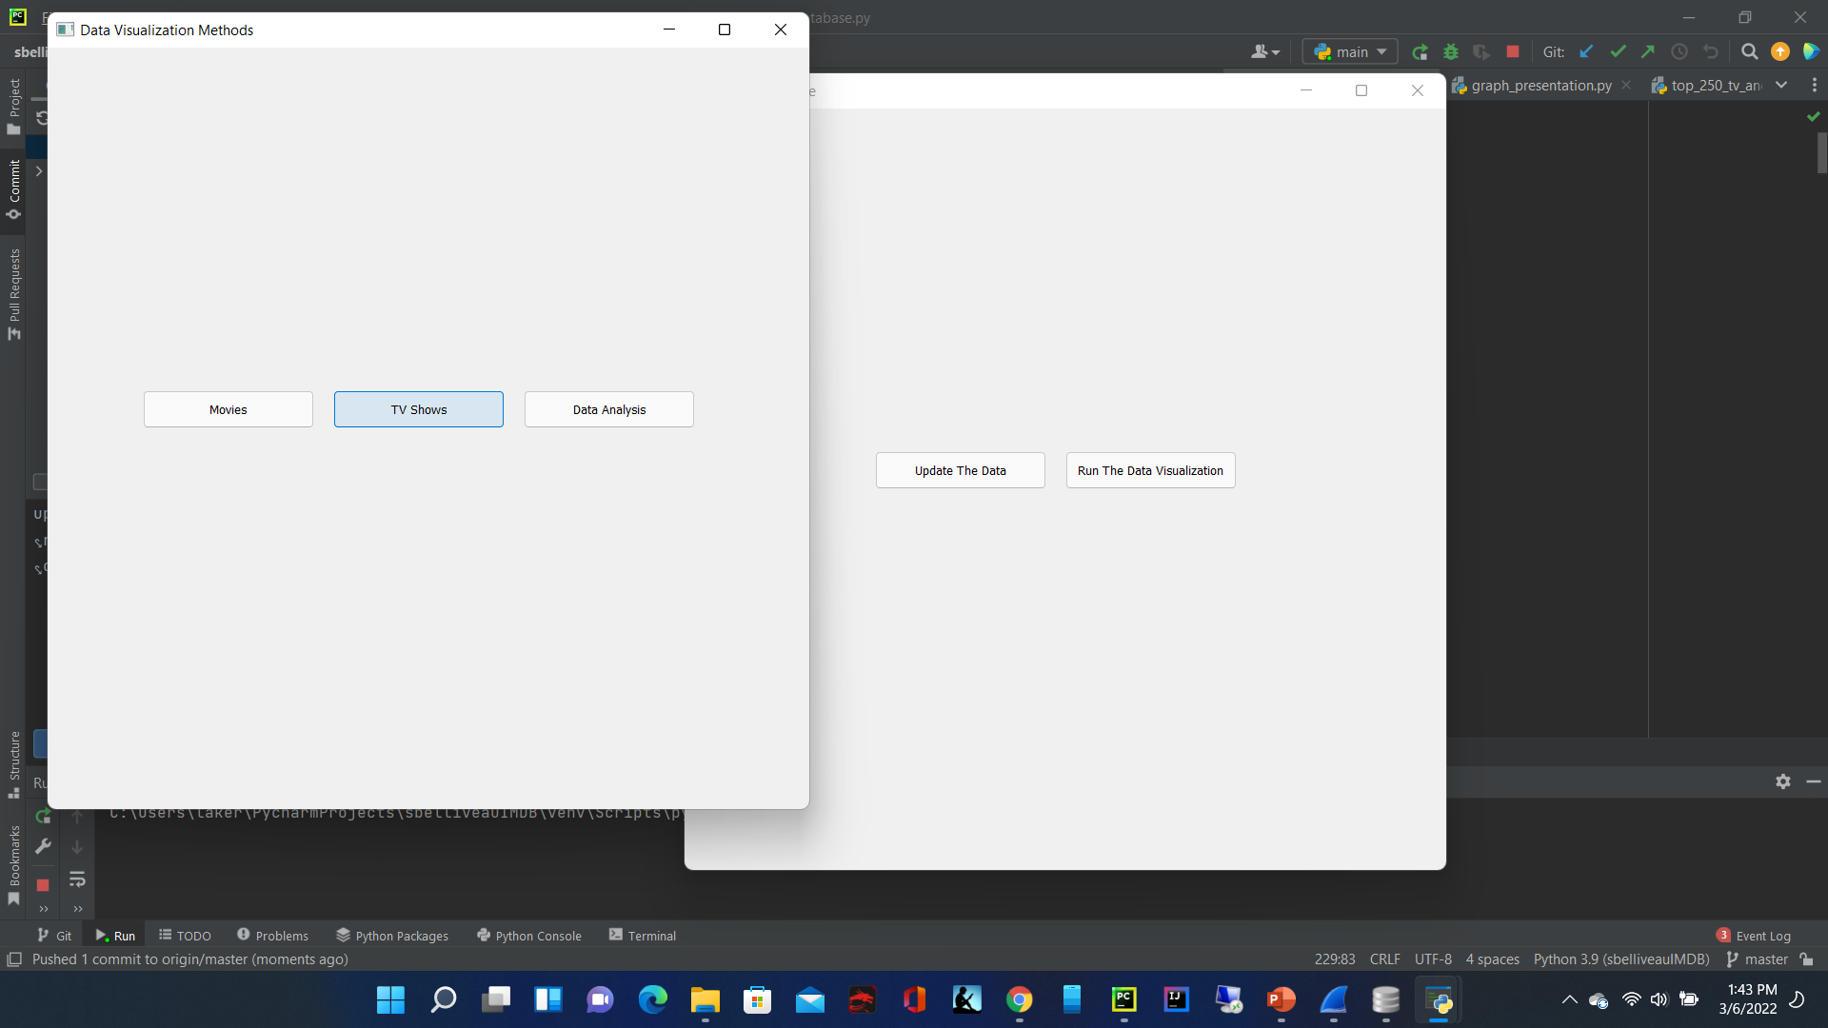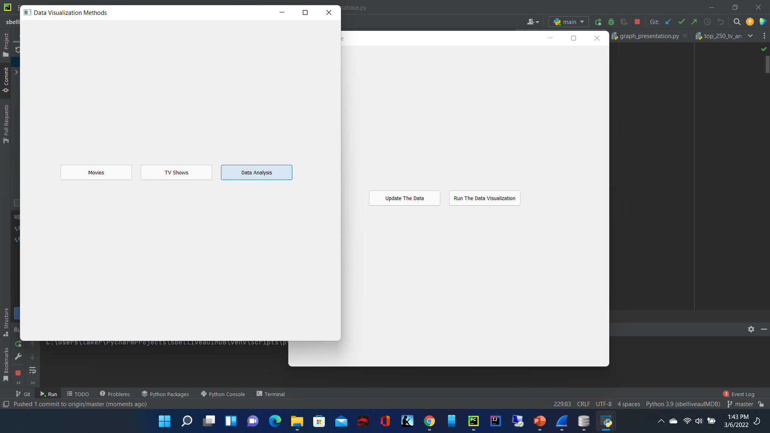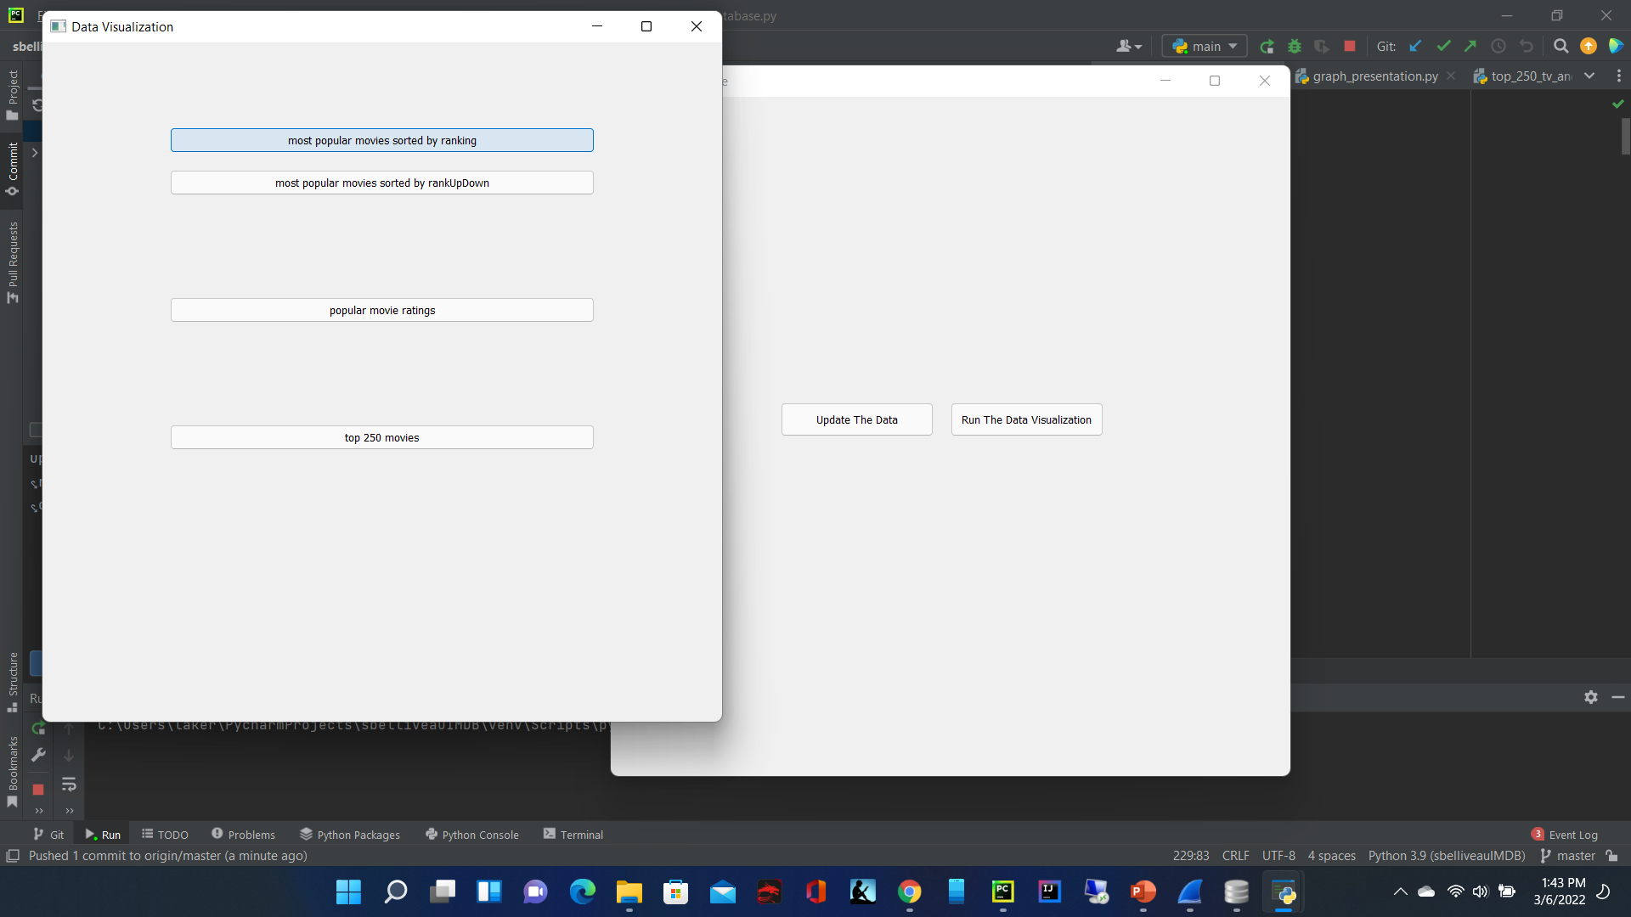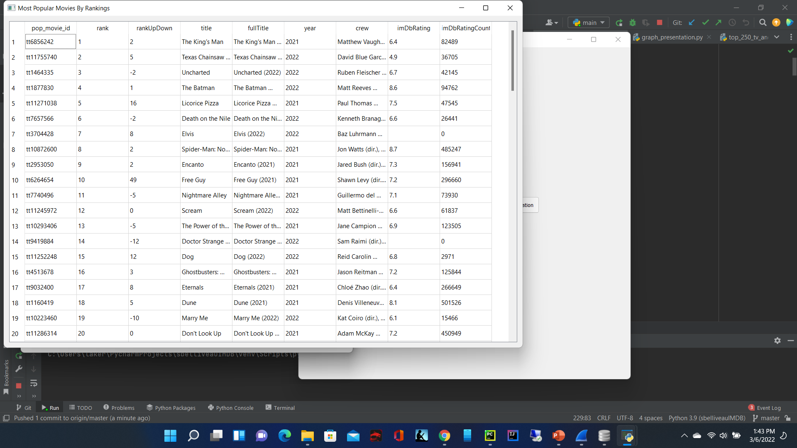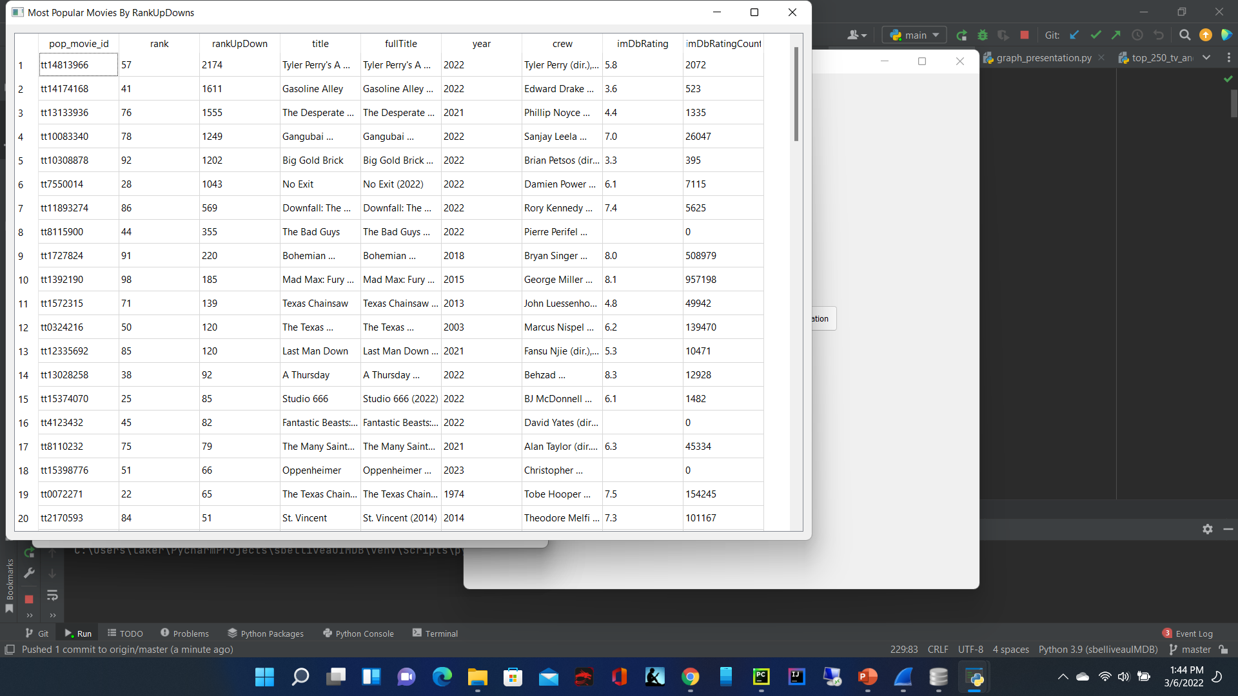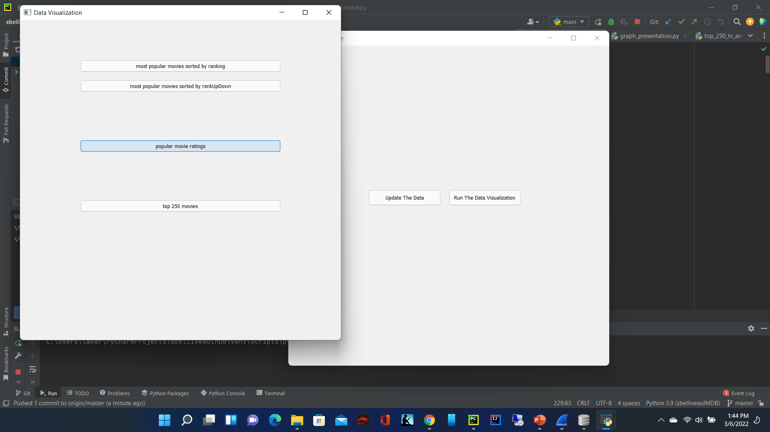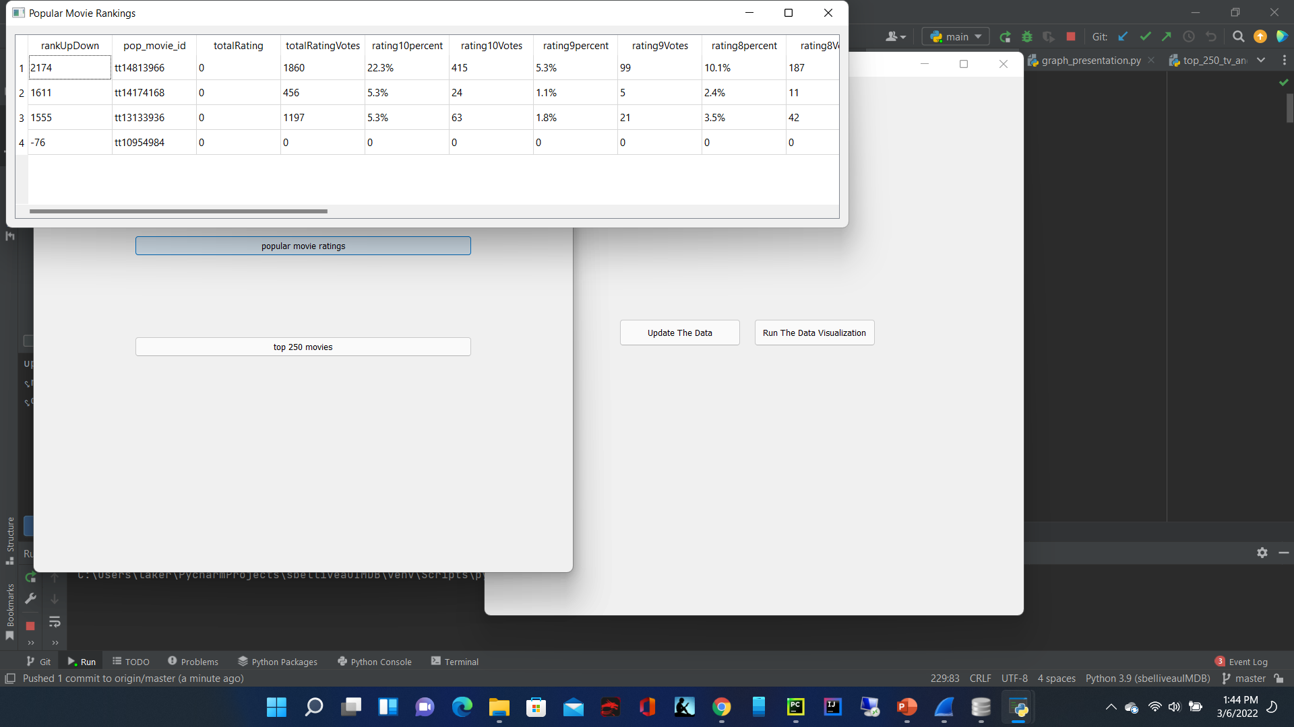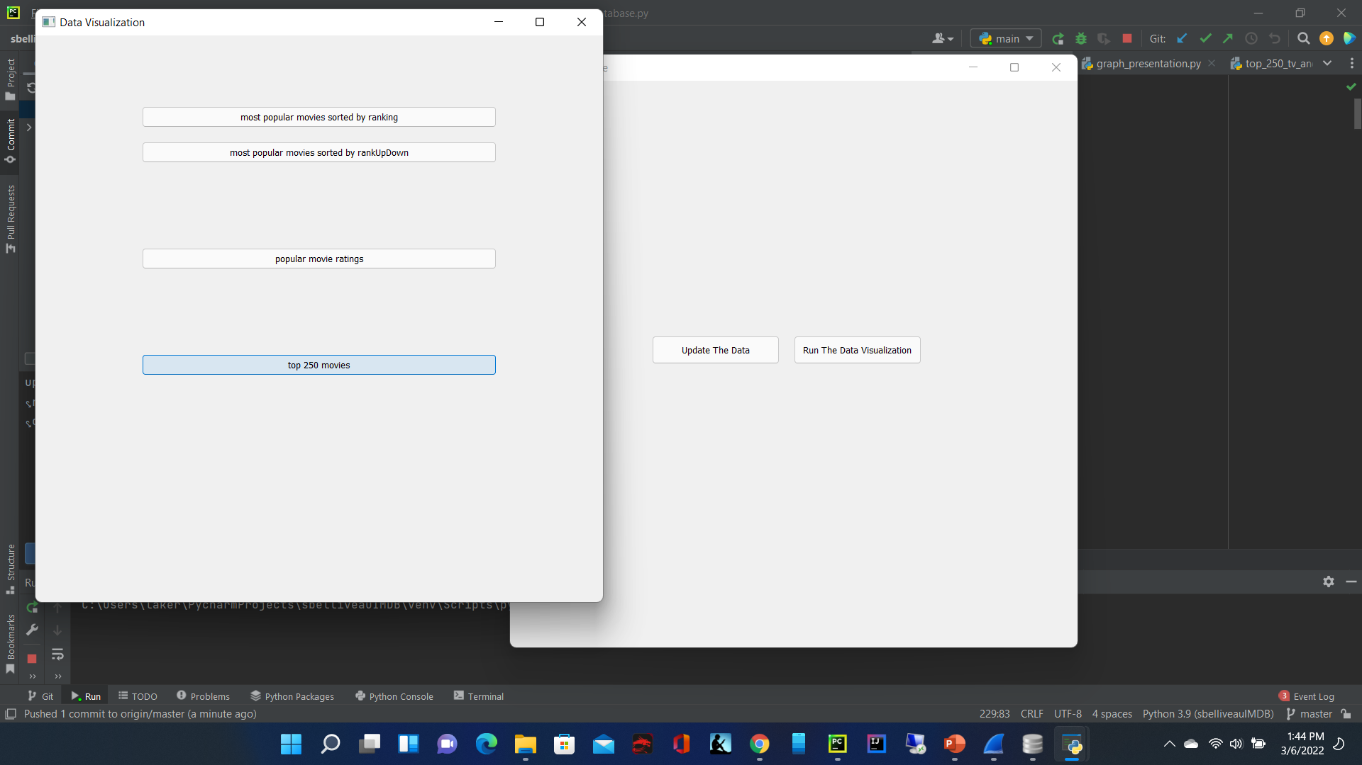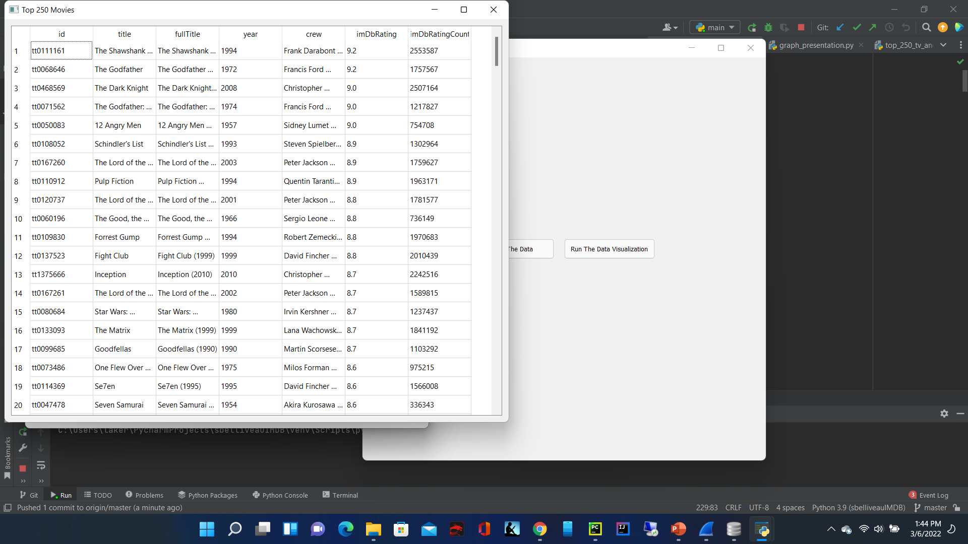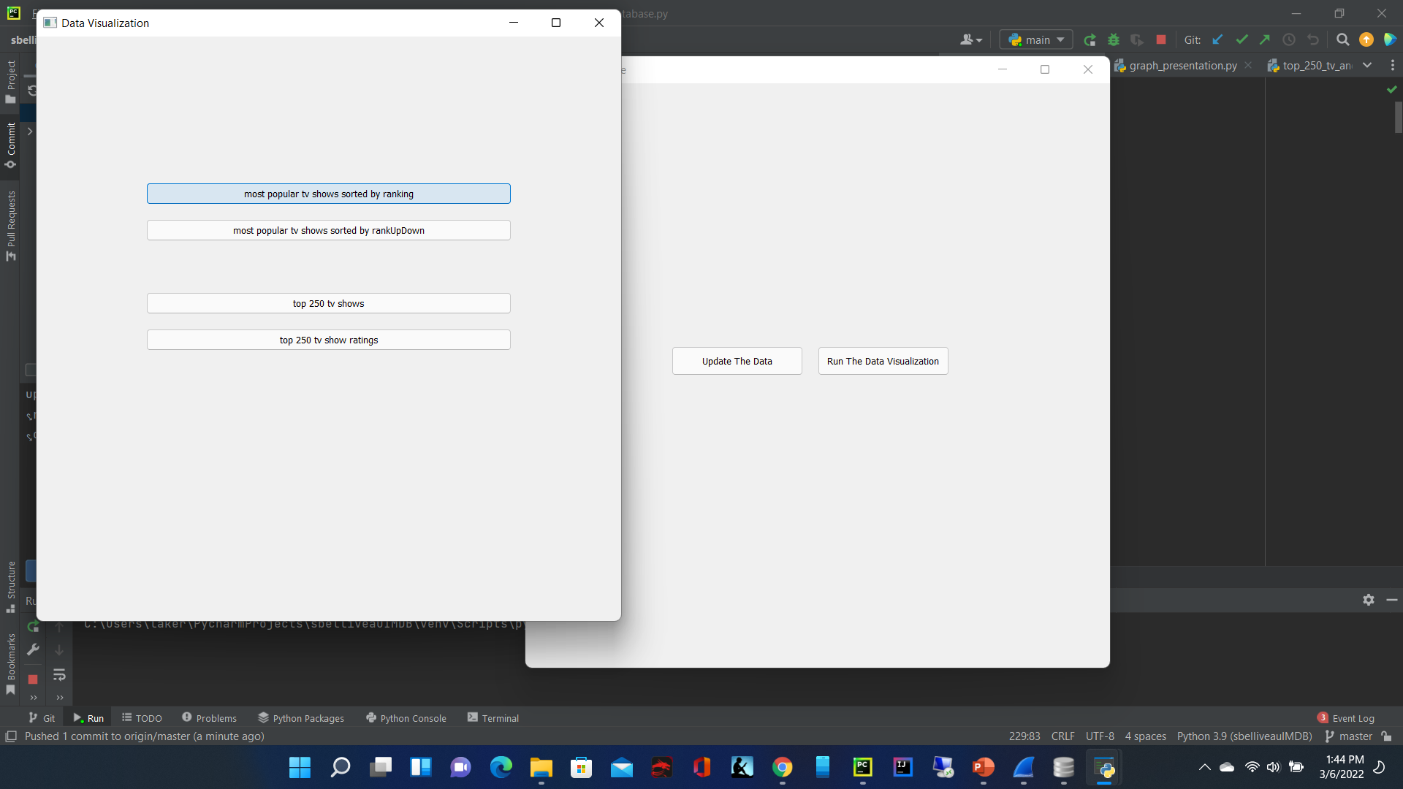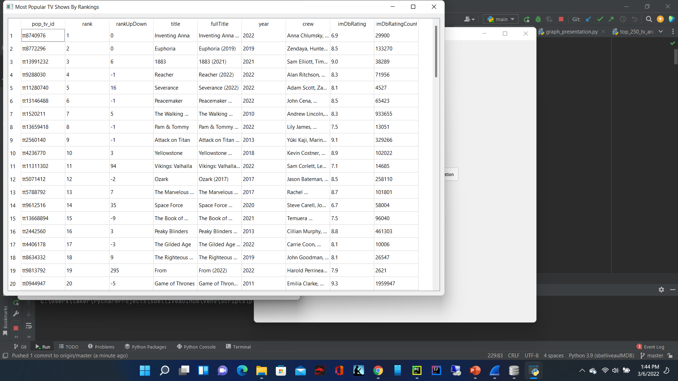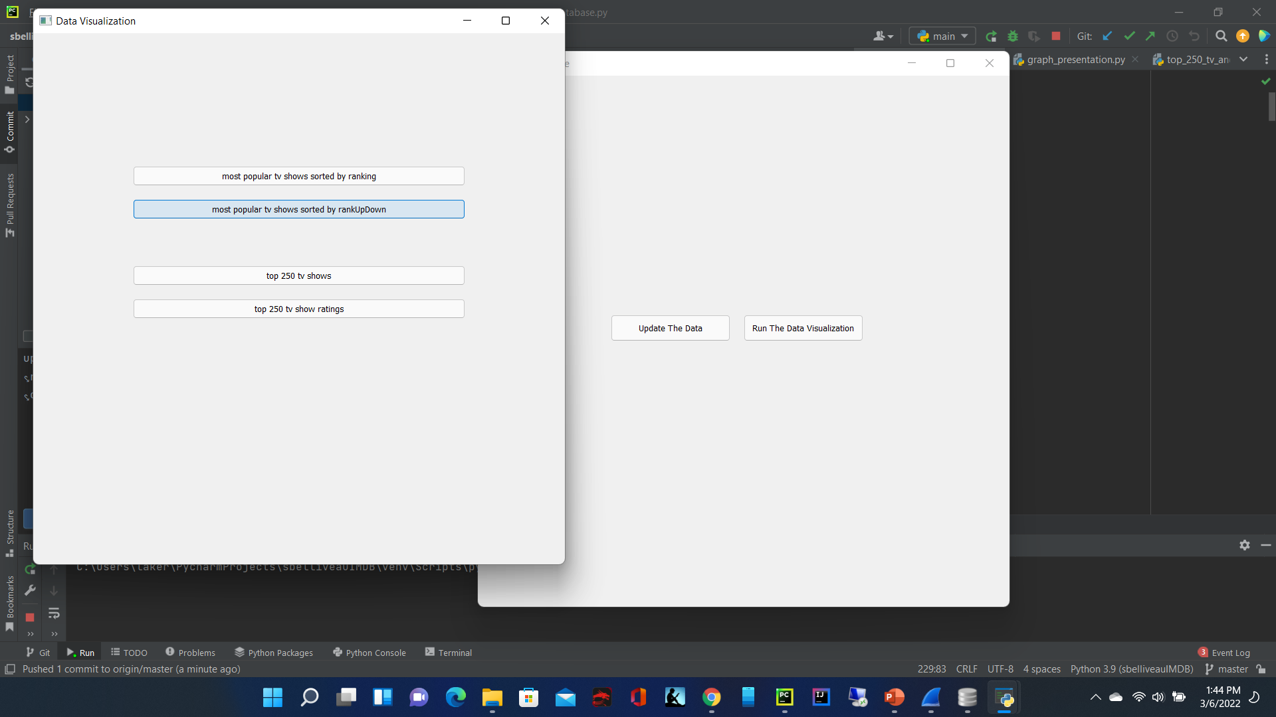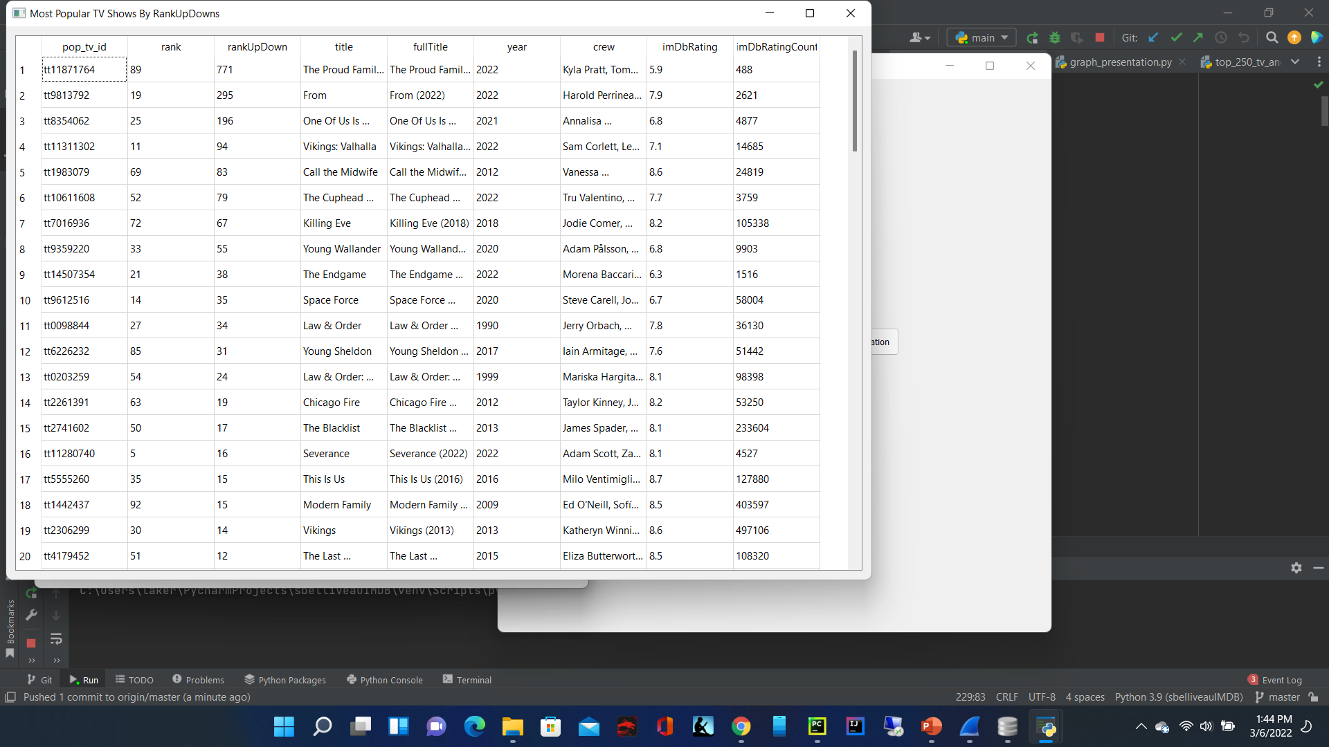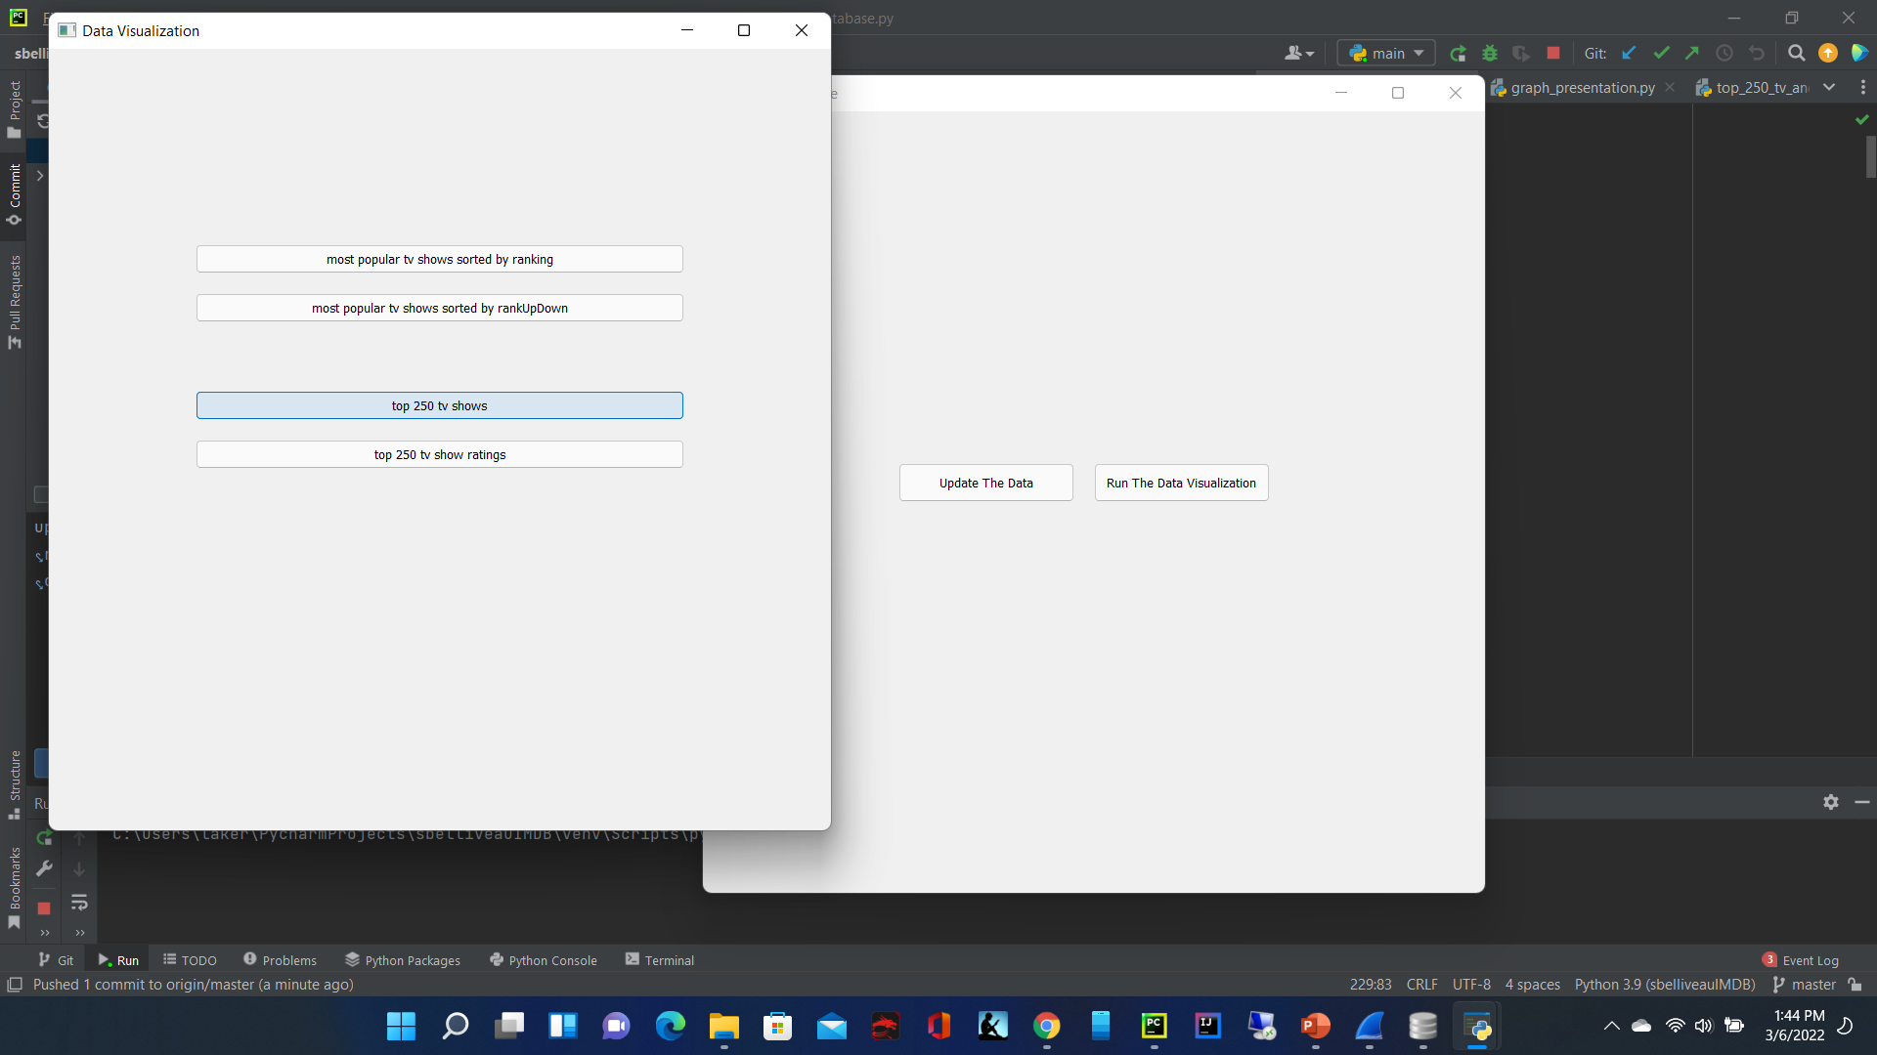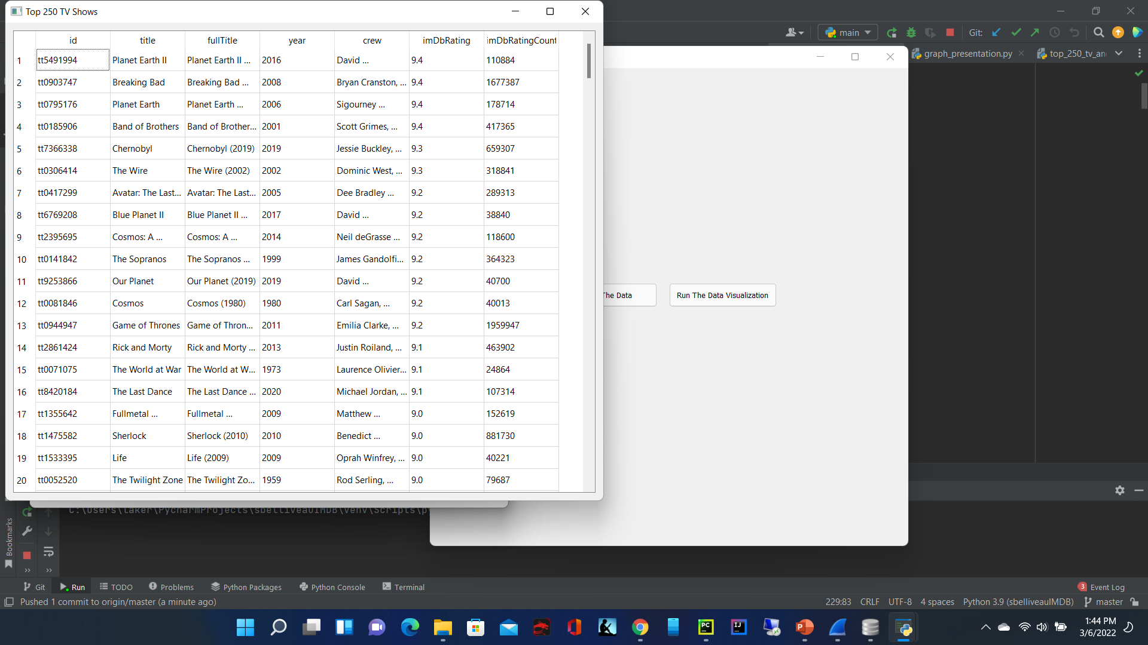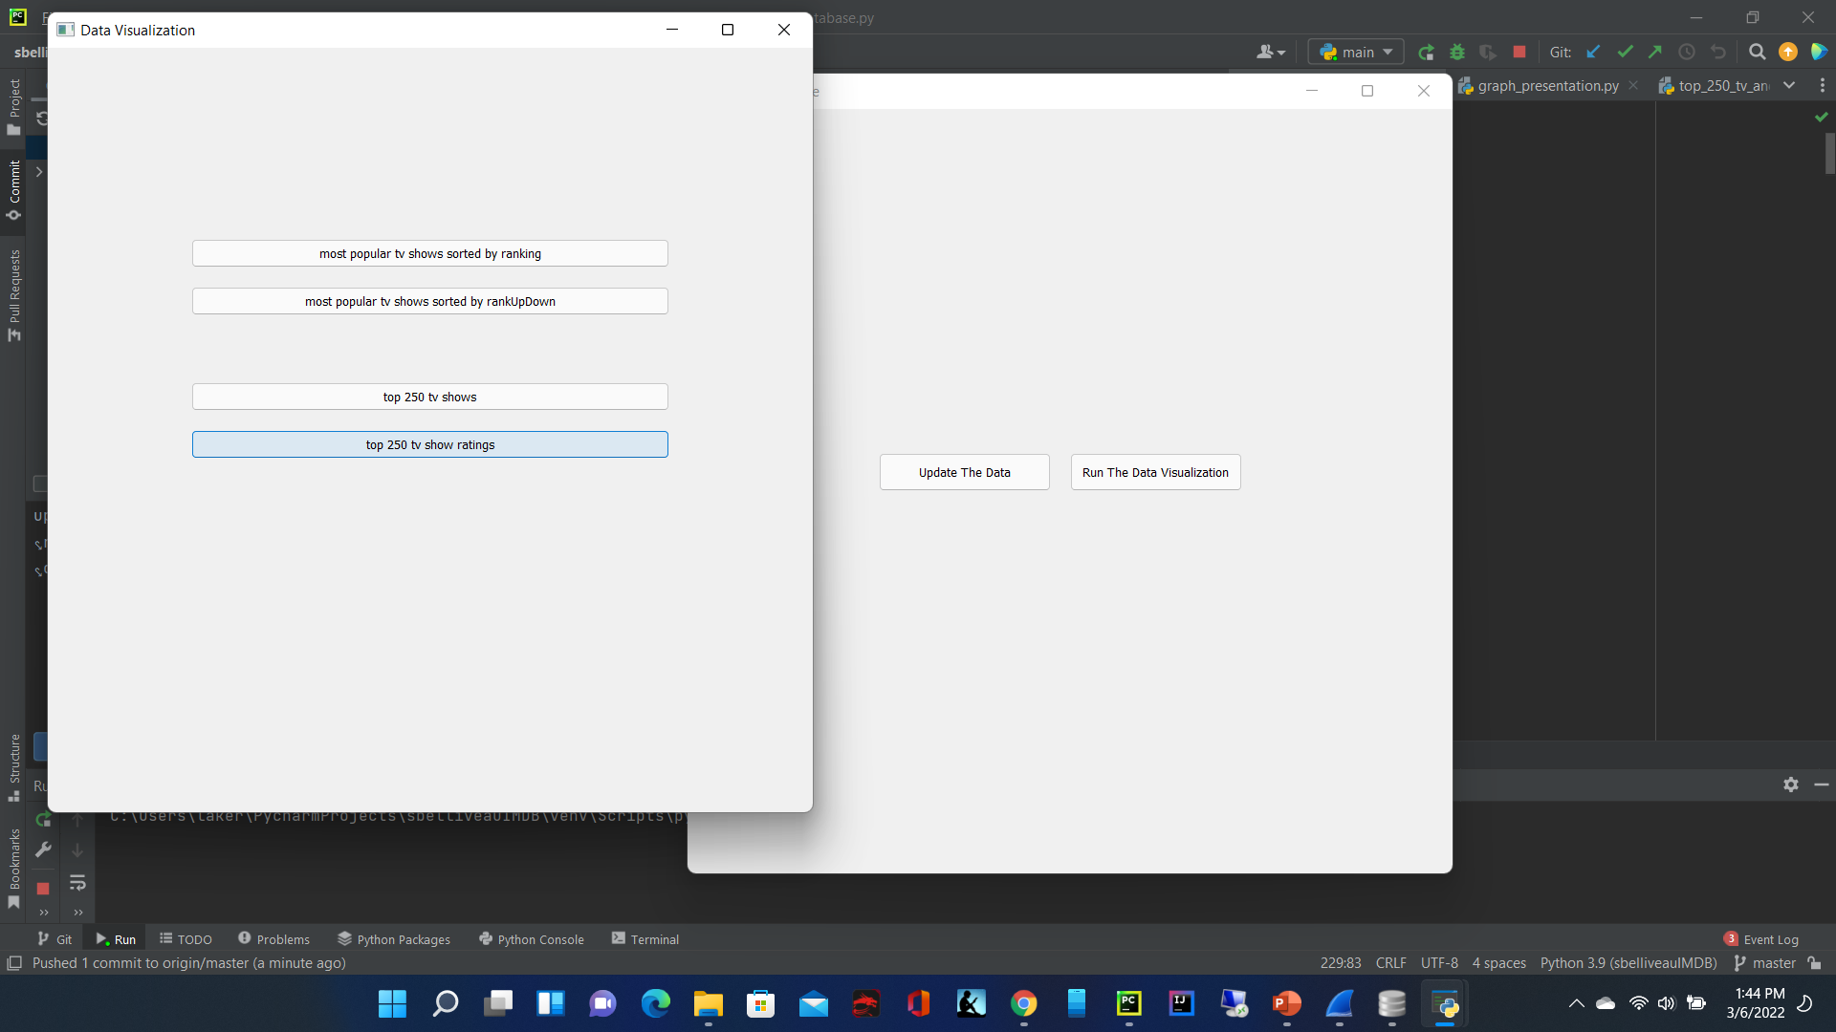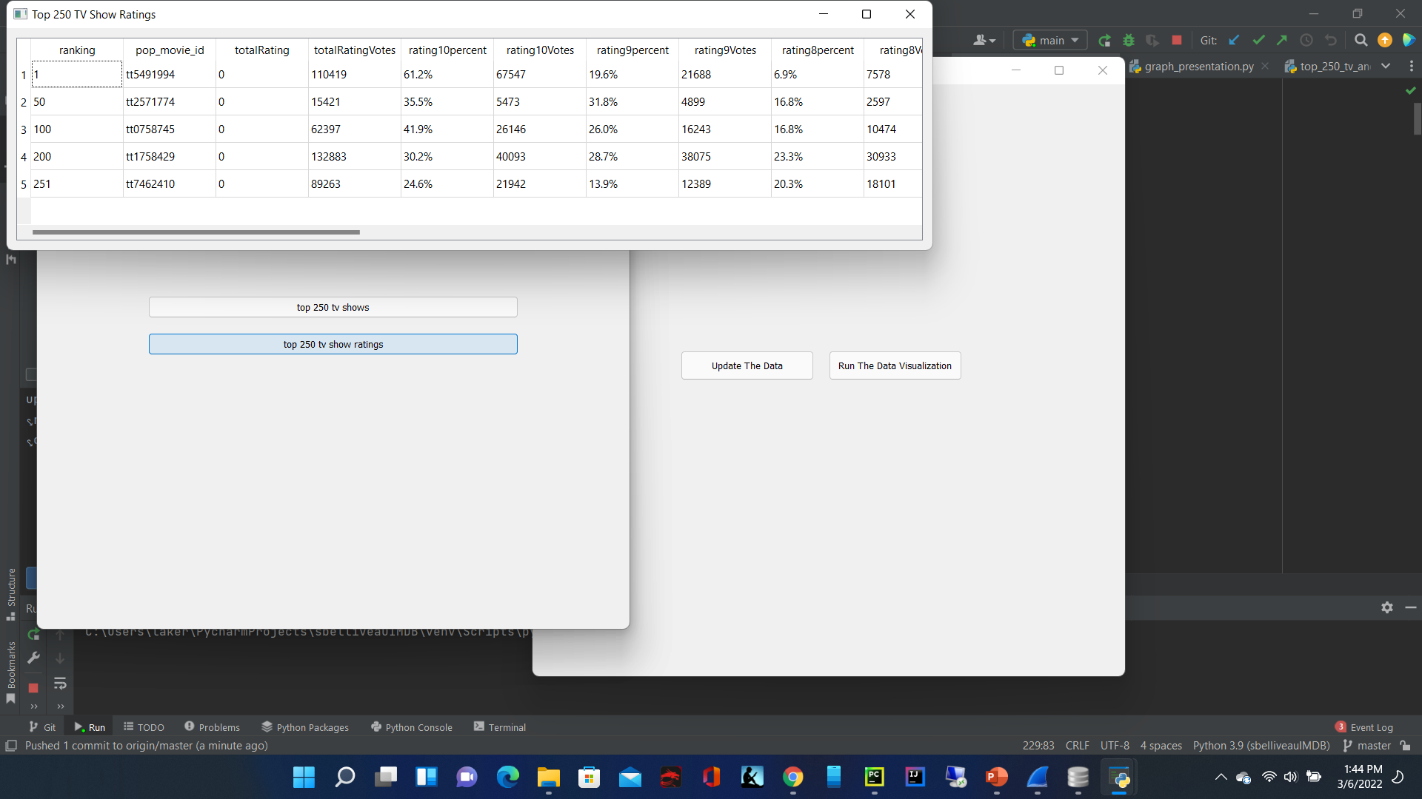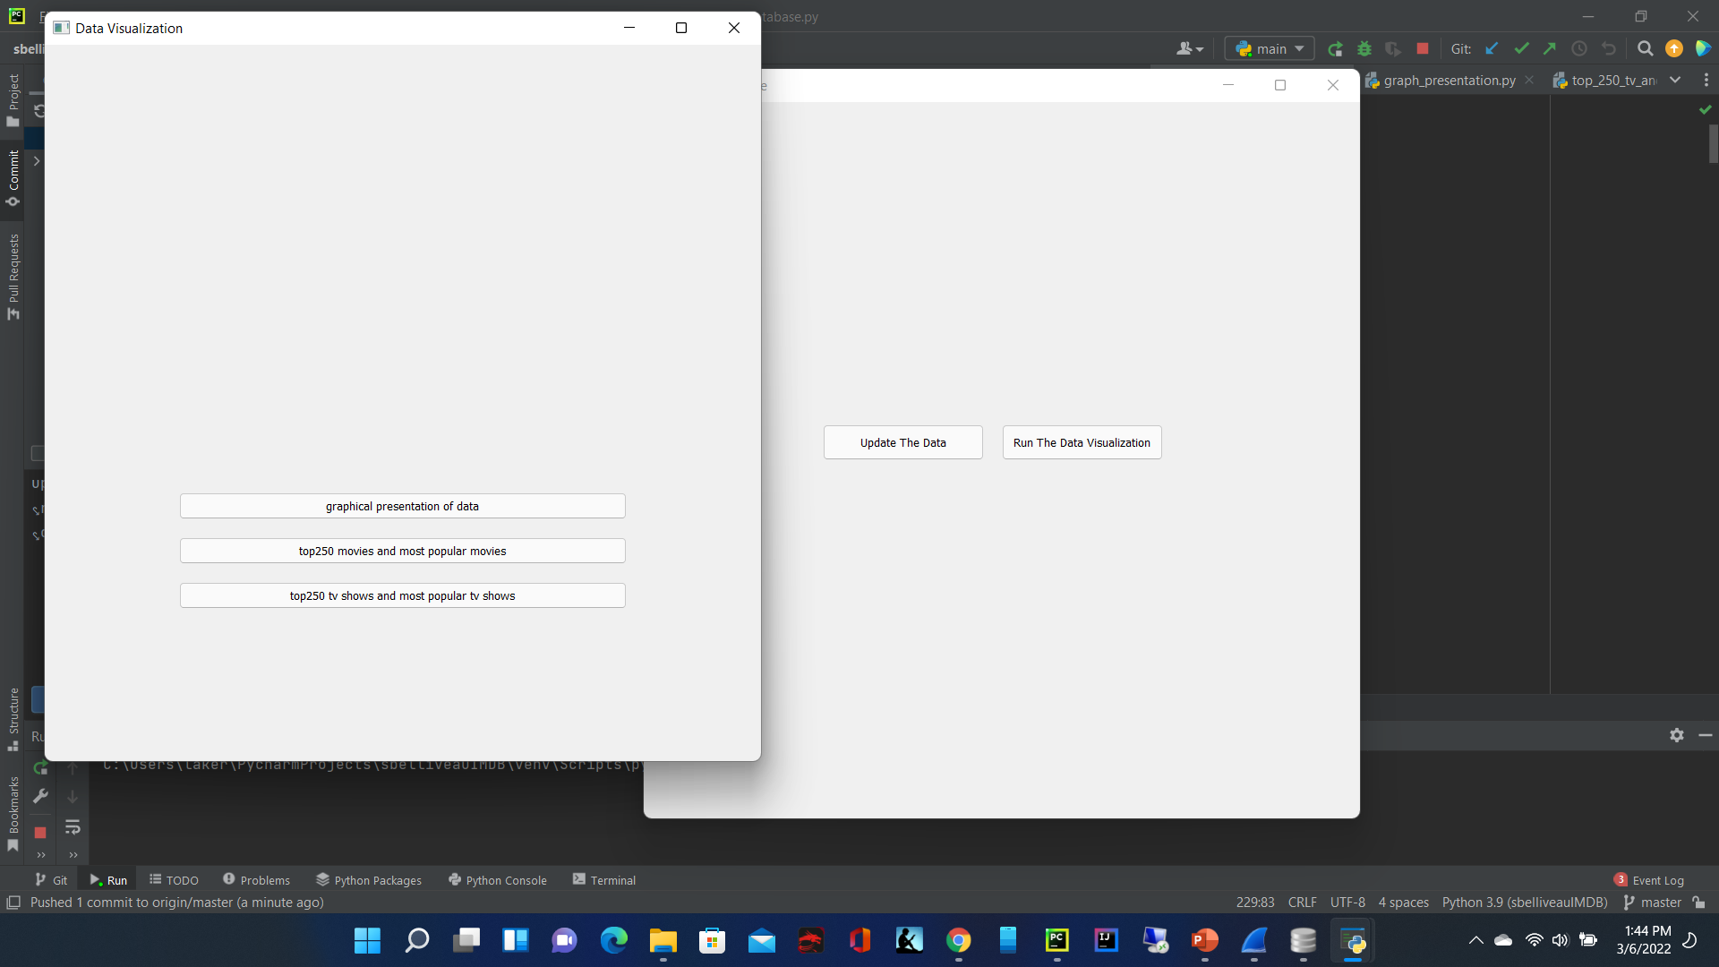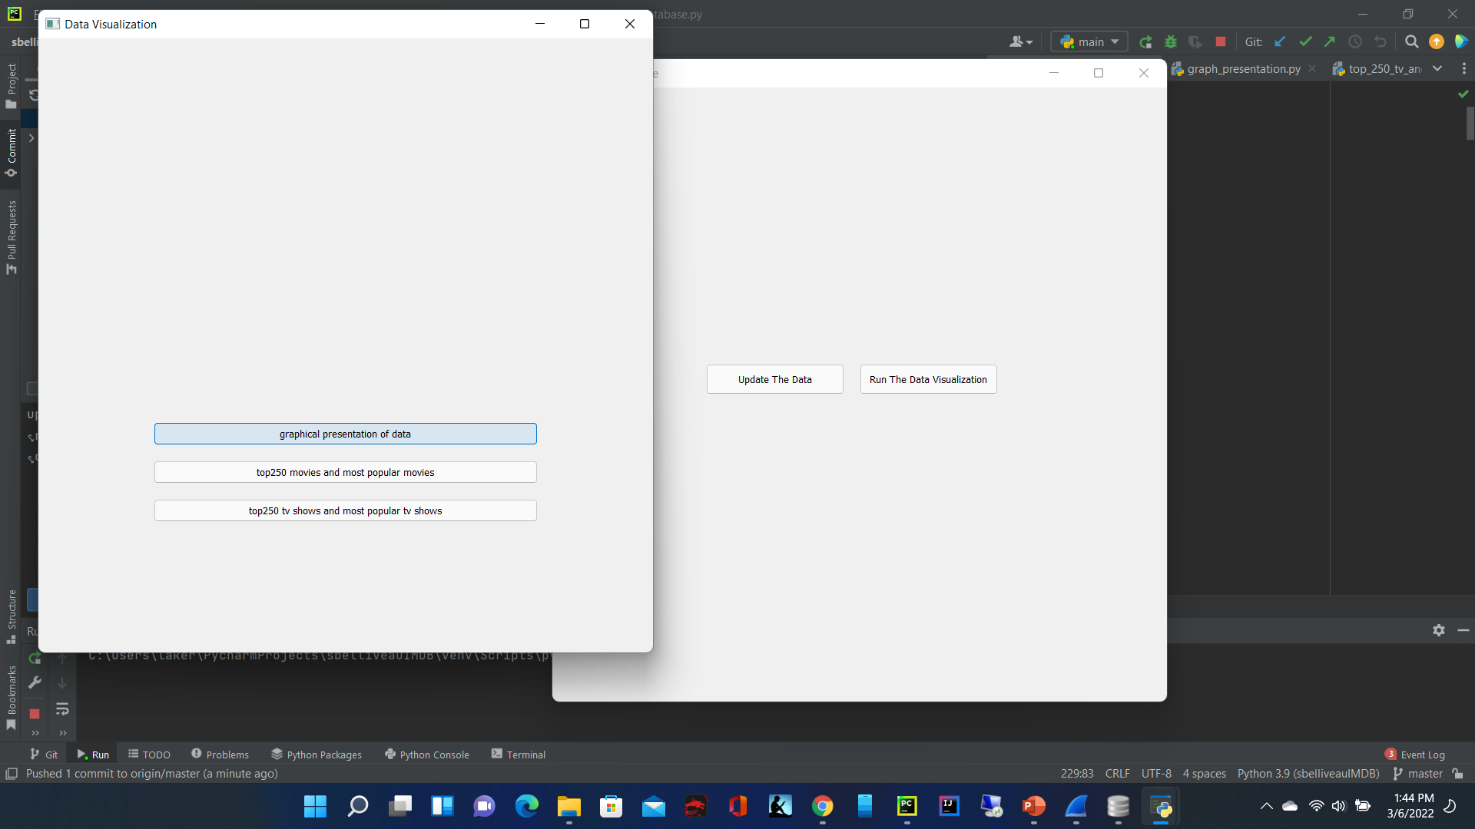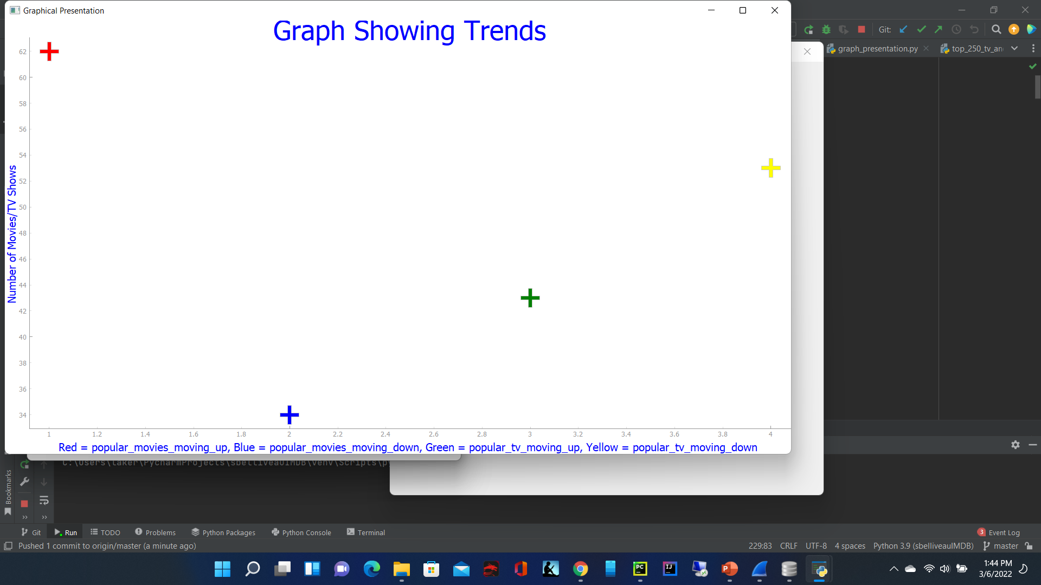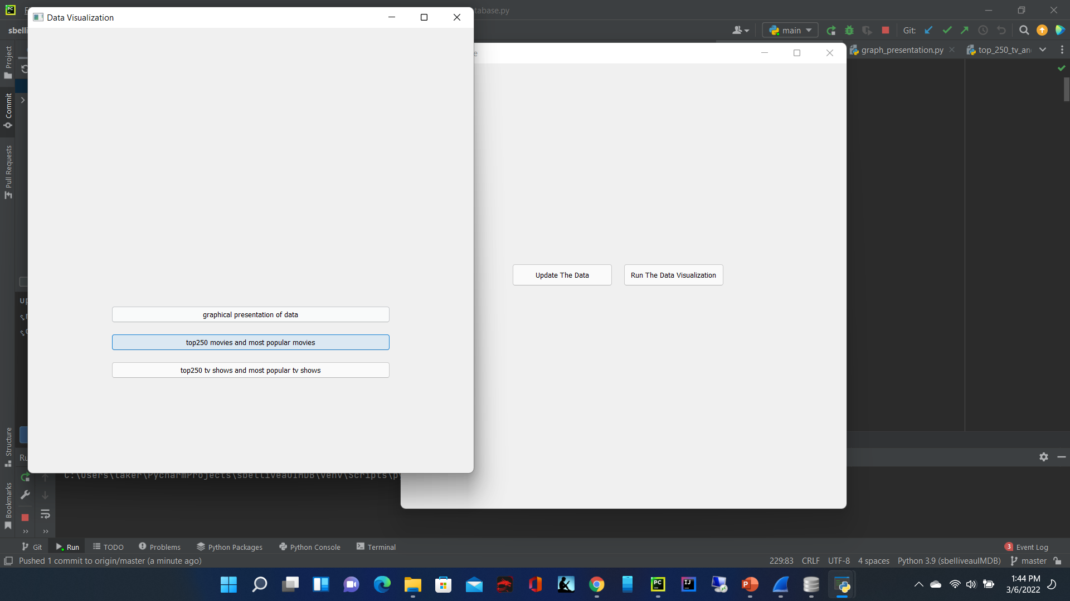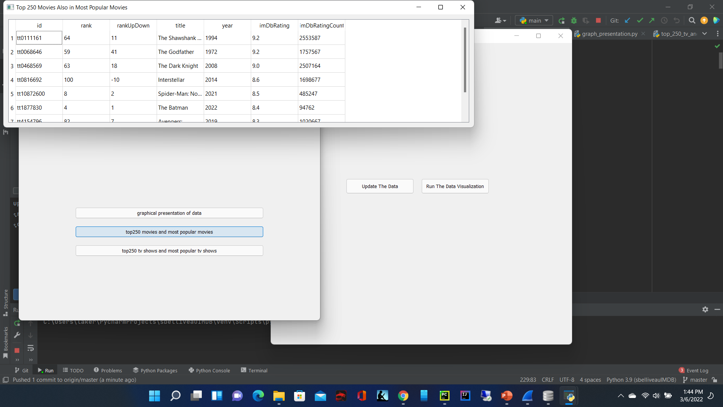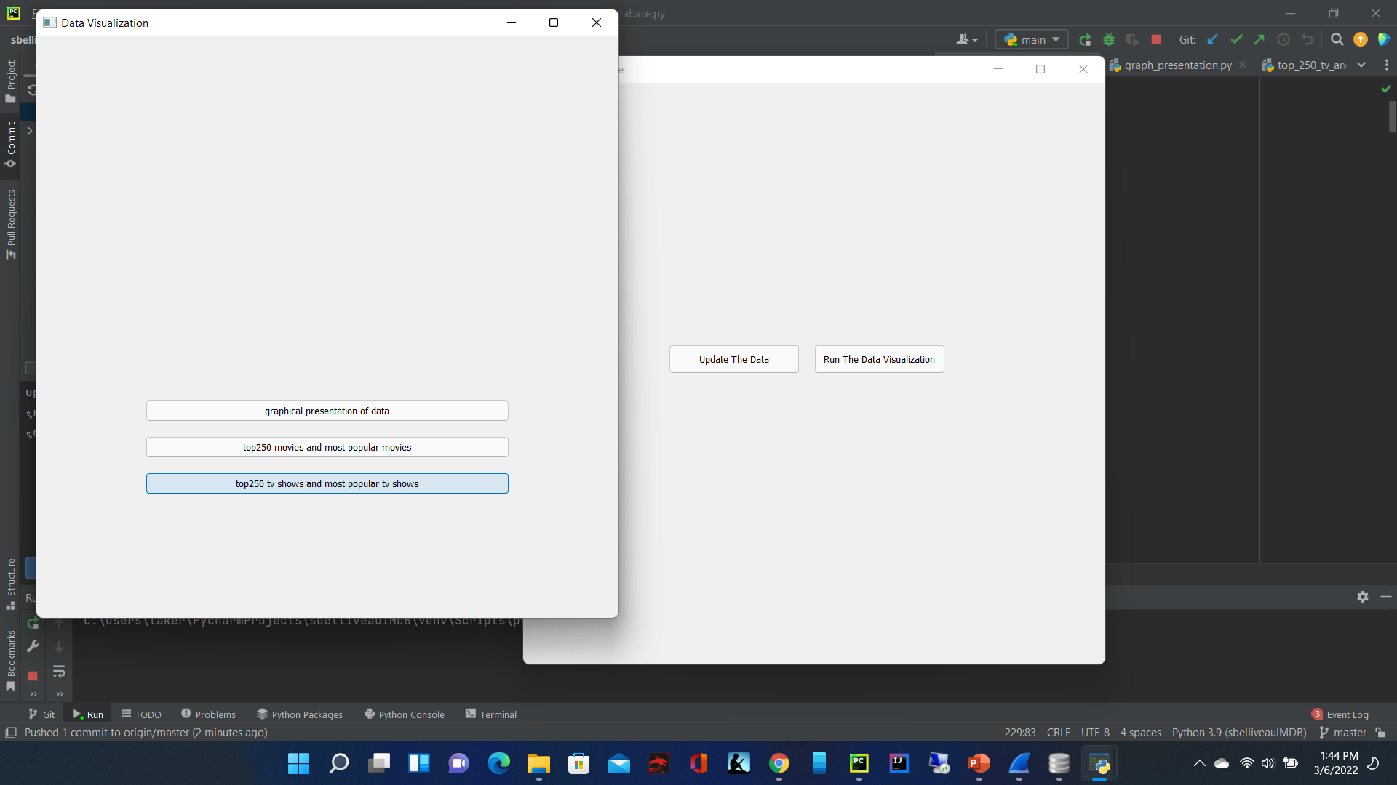

1. First the user should be able to open the window which will provide two options: to upload data or to run the data visualization
2. If the user clicks upload data button, it should run selected functions from the imdb_setup_database python file, in the terminal it should say something like out of range to indicate the database has been ran
3. If the user selects the run the data visualization button a new window should be toggled successfully and the user will be presented with three options: Movies, TV Shows or Data Analysis
4. If user selects Movies, a new window will appear with 4 options: most popular movies sorted by ranking, most popular movies sorted by rankUpDown, popular movie ratings, top250 movies
5. Most popular movies by ranking should display the database table in a table format inside a separate window displaying ranking from 1 to 100
6. Most popular movies by rankUpDown should display the database table in a table format inside a separate window displaying rankUpDowns from greatest to smallest
7. Popular movie ratings should display ratings in table format inside a separate window
8. Top250 movies should displaying table inside a table format inside a separate window
9. If the user selects TV shows, the user will be given 4 options: most popular tv shows sorted by ranking, most popular tv shows sorted by rankUpDown, top 250 tv shows and top 250 tv show ratings
10. Most popular tv shows by ranking should display the database table in a table format inside a separate window displaying ranking from 1 to 100
11. Most popular tv shows by rankUpDown should display the database table in a table format inside a separate window displaying rankUpDowns from greatest to smallest
12. Top250 tv shows should displaying table inside a table format inside a separate window
13. Top250 tv show ratings should display ratings in table format inside a separate window
14. If user selects Data Analysis a separate window should display with three options, graphical presentation of data, top250 movies and most popular movies and top250 tv shows and most popular tv shows
15. Graphical presentation of data should display a graph with markings that indicate popular movies moving up, popular movies moving down, popular tv shows moving up and popular tv shows moving down and all markings should be color coded with labels
16. Top250 movies and most popular movies should display a table in a separate window with almost all entries from every table like id, rank, rankUpDown, title, year, imDbRating, imDbRating Count
17. Top250 tv shows and most popular tv shows should display a table in a separate window with almost all entries from every table like id, rank, rankUpDown, title, year, imDbRating, imDbRating Count